MINISTRY OF EDUCATION AND SCIENCE KAZAKHSTAN

"NPJSC Eurasian National University named after L. N. Gumilyov"

report

for the course project

**“Pharmacy”**

Done by Zulkhayratuly Y.

Astana, 2024

**Short description**

**For a course project “Pharmacy”**

**Zulkhayratuly Yerlan**

Assignment

Information and Reference System: “Pharmacy”

The information and reference system must ensure the storage of data on medicines and other medicinal products, as well as pharmacies.

Pharmacy details should include:

• medication (name, description, manufacturer, strength, dosage form),

• pharmacy types(name, address, phone number),

• prescriptions (date of prescribed time quantity, refills).

The interaction between patient and doctor should be:

• patient, his or her fullname, date of birth, gender, address, phone number,

• prescriber full name, specialty, clinic name, phone number,

• dispensation of medications, its dispensed date, quantity dispensed, dispensing pharmacist,

• insurance provider, name, address, phone number,

• patient insurance, the insurance provider id and patient id with the policy number.

The information system must provide for different categories of users: pharmacy staff, patients, administrators.

**Introduction:**

In today's healthcare landscape, the efficient management of pharmaceutical data is paramount to ensuring the safety, accuracy, and accessibility of medication-related information. Pharmacy Information Systems (PIS) play a crucial role in this endeavor, serving as the backbone of operations within pharmacies worldwide. These systems encompass a broad spectrum of functionalities, ranging from managing patient profiles and medication dispensation to inventory control and regulatory compliance.

Pharmacy Information Systems: A Vital Component of Modern Healthcare

Pharmacy Information Systems (PIS) are integral to the functioning of pharmacies in countries across the globe. With the evolution of technology and the increasing complexity of healthcare delivery, the role of PIS has expanded beyond mere record-keeping to encompass a wide array of critical functions aimed at enhancing patient care, streamlining operations, and ensuring adherence to regulatory standards.

Key Features and Functionalities:

At the heart of any Pharmacy Information System lies its ability to capture, store, and manage vast amounts of pharmaceutical data. This includes patient information such as medical histories, allergies, and medication profiles, as well as details related to prescriptions, medications, prescribers, and pharmacies. Through seamless integration with electronic health records (EHRs) and other healthcare systems, PIS facilitates the sharing of essential information across healthcare settings, promoting continuity of care and patient safety.

Furthermore, PIS provides sophisticated tools for medication management, including functionalities for prescribing, dispensing, and administering medications. These systems help healthcare professionals verify medication orders, check for potential drug interactions or allergies, and ensure accurate dosage calculations. Automated alerts and decision support systems embedded within PIS serve as invaluable safeguards, alerting users to potential errors or discrepancies and promoting best practices in medication management.

Moreover, Pharmacy Information Systems play a pivotal role in inventory management, helping pharmacies track medication stock levels, monitor expiration dates, and streamline the procurement process. By optimizing inventory levels and reducing waste, PIS contribute to cost containment efforts while ensuring the availability of essential medications to meet patient needs.

Regulatory Compliance and Quality Assurance:

In an era of stringent regulatory requirements and heightened quality standards, Pharmacy Information Systems serve as indispensable tools for ensuring compliance with industry regulations and accreditation standards. From maintaining accurate records of controlled substances to adhering to medication labeling requirements, PIS support pharmacies in meeting regulatory obligations and upholding patient safety protocols.

Furthermore, PIS facilitate quality assurance initiatives by providing robust reporting and analytics capabilities. Through data-driven insights and performance metrics, pharmacies can identify areas for improvement, monitor key performance indicators, and implement evidence-based practices to enhance the quality and efficiency of pharmaceutical care delivery

Global Perspectives on Pharmacy Information Systems:

The adoption and utilization of Pharmacy Information Systems vary widely across different countries and healthcare systems. While some nations have embraced advanced electronic prescribing and medication management technologies, others continue to rely on traditional paper-based systems or face challenges related to infrastructure, funding, and workforce capacity.

In developed countries, such as the United States, Canada, and parts of Europe, Pharmacy Information Systems are ubiquitous, with widespread implementation across community pharmacies, hospital settings, and other healthcare facilities. These systems leverage cutting-edge technologies, such as cloud computing, interoperable data standards, and artificial intelligence, to deliver seamless and integrated pharmacy services.

Conversely, in developing regions and low-resource settings, the adoption of Pharmacy Information Systems may be more limited due to economic constraints, technological barriers, and healthcare infrastructure challenges. Nevertheless, efforts are underway to expand access to PIS and leverage mobile health (mHealth) solutions to overcome logistical hurdles and improve medication management in underserved populations.

**Part 1. Jiro**

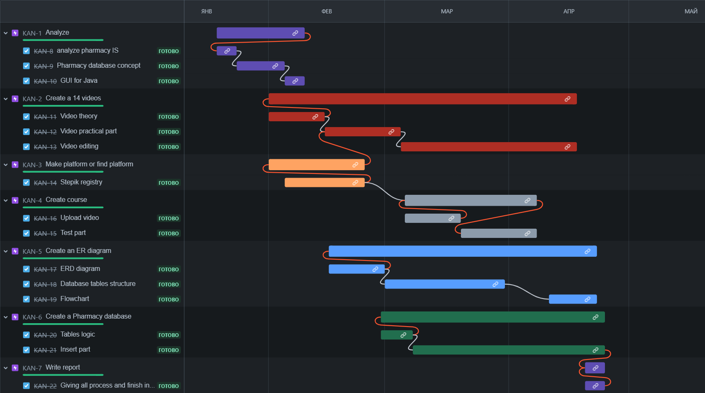

Jiro and Pharmacy Plan:

Jiro is a fictitious character who has embarked on the journey of establishing a pharmacy business, driven by a passion for healthcare and a vision to provide quality pharmaceutical services to the community. As Jiro ventures into the realm of entrepreneurship, he recognizes the importance of developing a comprehensive pharmacy plan to guide his endeavors and ensure the success of his venture.

The pharmacy plan serves as a roadmap for Jiro's business, outlining key objectives, strategies, and actions necessary to achieve his goals. Central to this plan is the integration of a robust Pharmacy Information System (PIS), which will serve as the backbone of Jiro's operations and facilitate the efficient management of pharmaceutical data.

**Part 2. Database Design**

2.1 Creating an ER model

The design of the database for the Pharmacy Information System (PIS) is a critical step in ensuring the efficient storage, retrieval, and management of pharmaceutical data. This chapter focuses on the process of designing the database schema, including the creation of an Entity-Relationship (ER) model, transition from the ER model to database schemas, and reduction to normal forms.

The first step in database design is to create an Entity-Relationship (ER) model that represents the entities, attributes, and relationships within the pharmacy domain. The ER model serves as a conceptual framework for understanding the structure of the database and defining the interactions between different entities.

Key entities in the ER model for the Pharmacy Information System include:

* Medication
* Pharmacy
* Prescription
* Patient
* Prescriber
* Dispensation
* InsuranceProvider
* PatientInsurance

Attributes and relationships are identified for each entity, capturing essential information and defining the associations between entities. The ER model provides a visual representation of the database structure, laying the foundation for the creation of database schemas.

The creation of an Entity-Relationship (ER) model is a crucial step in the database design process, providing a visual representation of the entities, attributes, and relationships within the Pharmacy Information System (PIS). The ER model serves as a conceptual blueprint for designing the database schema, enabling stakeholders to understand the structure of the database and the interactions between different entities.

The first task in creating the ER model is to identify the main entities within the pharmacy domain. These entities represent real-world objects or concepts that are relevant to the system. In the context of the Pharmacy Information System, key entities include:

Medication: Represents pharmaceutical products available within the system, including attributes such as MedicationID, Name, Description, Manufacturer, Strength, and DosageForm.

Pharmacy: Represents physical pharmacy locations, including attributes such as PharmacyID, Name, Address, and PhoneNumber.

Prescription: Represents medication orders issued by prescribers to patients, including attributes such as PrescriptionID, PatientID, PrescriberID, MedicationID, DatePrescribed, Quantity, and Refills.

Patient: Represents individuals receiving healthcare services, including attributes such as PatientID, FirstName, LastName, DateOfBirth, Gender, Address, and PhoneNumber.

Prescriber: Represents healthcare providers authorized to prescribe medications, including attributes such as PrescriberID, FirstName, LastName, Specialty, ClinicName, and PhoneNumber.

Dispensation: Represents the fulfillment of prescriptions at pharmacy locations, including attributes such as DispensationID, PrescriptionID, PharmacyID, DateDispensed, QuantityDispensed, and DispensingPharmacist.

InsuranceProvider: Represents organizations providing insurance coverage for medications and healthcare services, including attributes such as InsuranceProviderID, Name, Address, and PhoneNumber.

PatientInsurance: Represents the relationship between patients and insurance providers, including attributes such as PatientID, InsuranceProviderID, and PolicyNumber.

Once the entities are identified, the next step is to define the attributes and relationships for each entity. Attributes represent properties or characteristics of entities, while relationships define associations between entities. For example, the Prescription entity has relationships with the Patient, Prescriber, and Medication entities. A prescription is associated with a specific patient who receives the medication, a prescriber who issues the prescription, and a medication that is prescribed.

Attributes such as DatePrescribed, Quantity, and Refills capture details about the prescription, including the date it was prescribed, the quantity of medication ordered, and the number of refills authorized.

The ER model is typically represented graphically using diagrams that depict entities as rectangles, attributes as ovals, and relationships as lines connecting entities. Cardinality indicators such as "1", "0..1", "1..*" are used to specify the cardinality of relationships.

The ER model provides a visual representation of the database structure, enabling stakeholders to visualize the entities, attributes, and relationships within the Pharmacy Information System and understand how data flows between different components of the system.

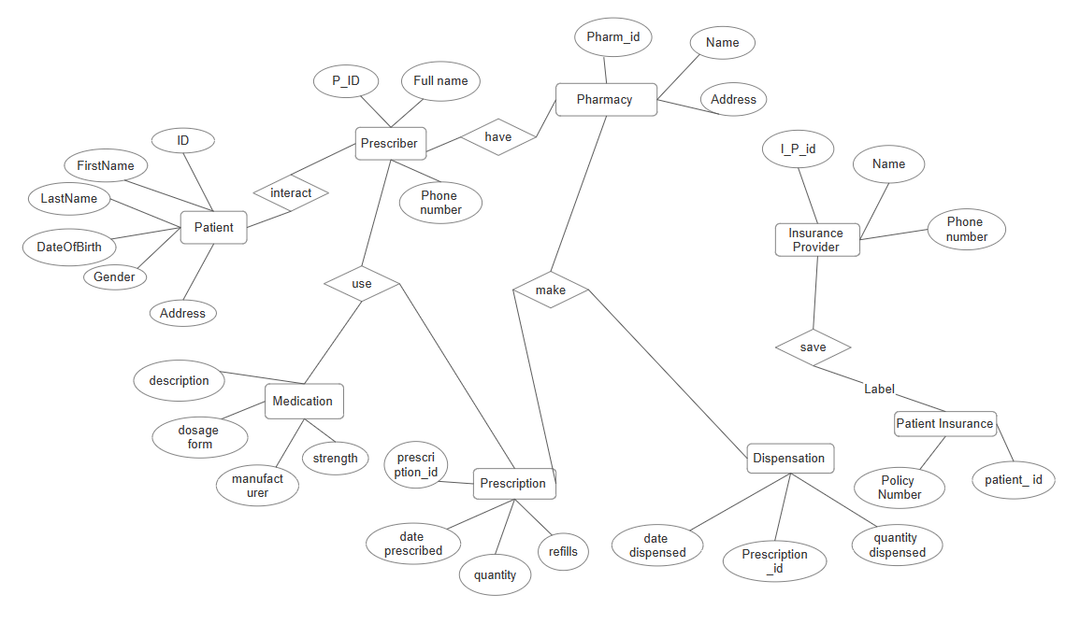

In the Pharmacy Information System, relationships between entities play a crucial role in capturing the connections and interactions between different components of the system. Here are some key relationships and their descriptions.

Prescription-Patient Relationship: Represents the association between a prescription and the patient for whom it is prescribed.

A prescription issued by a prescriber (e.g., physician, nurse practitioner) is linked to a specific patient who requires the medication. This relationship ensures that prescriptions are accurately assigned to the corresponding patients and facilitates medication management for individual patients.

Prescription-Prescriber Relationship: Represents the association between a prescription and the healthcare provider who issued the prescription.

When a healthcare provider prescribes medication to a patient, a relationship is established between the prescription and the prescriber. This relationship allows for tracking the prescribing practices of healthcare providers, ensuring accountability, and facilitating communication between prescribers and pharmacists.

Prescription-Medication Relationship: Represents the association between a prescription and the medication that is prescribed.

Each prescription is linked to a specific medication that is prescribed to the patient. This relationship enables pharmacists to accurately dispense the prescribed medication, verify drug information, and ensure patient safety by checking for drug interactions and contraindications.

Dispensation-Pharmacy Relationship: Represents the association between a medication dispensation and the pharmacy where the dispensation occurs.

When a pharmacist dispenses medication to a patient, a relationship is established between the dispensation record and the pharmacy where the dispensation takes place. This relationship allows for tracking dispensation activities at different pharmacy locations, monitoring medication usage patterns, and managing pharmacy inventory.

Patient-InsuranceProvider Relationship: Represents the association between a patient and their insurance provider.

Each patient may have insurance coverage provided by an insurance provider. This relationship allows for verifying insurance eligibility, processing insurance claims, and determining patient copayments or coverage limitations. It facilitates seamless coordination between healthcare services and insurance benefits, ensuring that patients receive timely and cost-effective care.

These relationships within the ER model facilitate data integration, consistency, and integrity within the Pharmacy Information System. By defining clear associations between entities, the ER model lays the foundation for a robust and effective database schema that supports the complex interactions and workflows within the pharmacy domain.

2.2 Transition from ER model to database schemas

ER model is established, the next step is to translate it into database schemas consisting of tables, columns, and relationships. Each entity in the ER model corresponds to a table in the database schema, with attributes represented as columns within the table.

For example, the Medication entity in the ER model translates to a Medication table in the database schema, with attributes such as MedicationID, Name, Description, Manufacturer, Strength, and DosageForm.

Foreign key relationships are established between tables to enforce referential integrity and maintain data consistency. For instance, the Prescription table may have foreign key references to the Patient, Prescriber, and Medication tables to establish connections between prescriptions and associated entities.

Attributes identified in the ER model are represented as columns within the corresponding tables in the database schema. Each column is assigned a data type that specifies the kind of data that can be stored in the column (e.g., VARCHAR for text, INT for integers, DATE for dates).

For example, the Name attribute of the Medication entity may be represented as a VARCHAR column in the Medication table, while the Strength attribute may be represented as a VARCHAR or DECIMAL column to accommodate numeric values.

Relationships between entities in the ER model are translated into foreign key constraints in the database schema to enforce referential integrity and maintain data consistency. Foreign key constraints establish connections between tables based on the relationships defined in the ER model.

For example, in the Prescription table, foreign key references may be established to link the PrescriptionID column to the PatientID, PrescriberID, and MedicationID columns in the Patient, Prescriber, and Medication tables, respectively. These foreign key constraints ensure that each prescription is associated with the correct patient, prescriber, and medication records in the database.

**Part 3: About GUI project connected to Database(PostgreSQL)**

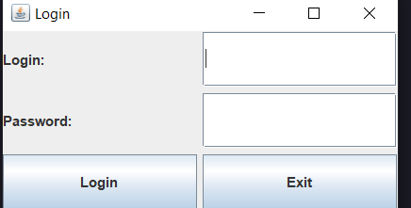

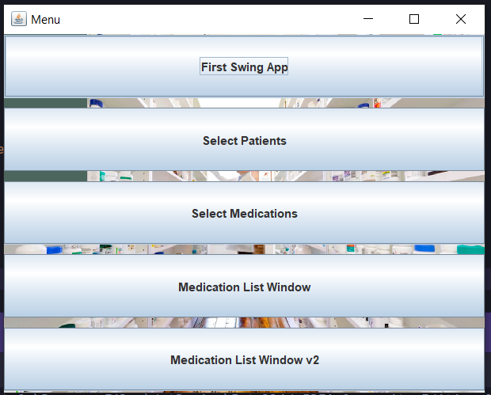

**Conclusion**

In the development of the Pharmacy Information System, a systematic approach was undertaken, encompassing the analysis, design, and implementation phases. The journey commenced with an exploration of the subject area, delineating the characteristics and requirements essential for crafting a robust information system tailored to the needs of pharmacies. Through meticulous examination, it became apparent that the system should encompass comprehensive data storage capabilities, encompassing details about medications, pharmacies, prescriptions, patients, prescribers, and dispensations.

The subsequent chapter delved into the realm of database design, elucidating the intricacies of creating an Entity-Relationship (ER) model as a blueprint for the database schema. By identifying entities, attributes, and relationships inherent to the pharmacy domain, a cohesive and structured model emerged, forming the foundation upon which the database would be built. The transition from the ER model to database schemas involved the creation of tables, indexes, triggers, and procedures, ensuring that the database architecture was aligned with the defined requirements.

Furthermore, the process of normalization was employed to optimize the database schema, minimizing redundancy and dependency while enhancing data integrity and efficiency. By adhering to First Normal Form (1NF), Second Normal Form (2NF), Third Normal Form (3NF), and Boyce-Codd Normal Form (BCNF) principles, the database design achieved a higher level of organization and coherence, paving the way for seamless data management and retrieval.

In the final chapter, the focus shifted towards the practical implementation of the database schema, where charts, tables, indexes, triggers, procedures, subqueries, and filters were created to materialize the designed system. Through the utilization of SQL statements and database management techniques, the Pharmacy Information System began to take shape, offering functionalities such as medication management, prescription tracking, patient information storage, and dispensation recording.

In culmination, the journey of developing the Pharmacy Information System encapsulates the convergence of theory and practice, where conceptual ideas are translated into tangible solutions to address real-world challenges. The system stands as a testament to the power of information technology in revolutionizing healthcare delivery, empowering pharmacies to streamline operations, enhance patient care, and contribute to the advancement of the pharmaceutical industry.

As we embark on the next phase of this endeavor, it is imperative to continue refining and optimizing the system, leveraging emerging technologies and best practices to meet evolving demands and stay at the forefront of innovation. With a steadfast commitment to excellence and a vision for the future, the Pharmacy Information System is poised to make a lasting impact on the healthcare landscape, ushering in a new era of efficiency, accessibility, and quality in pharmaceutical services.

References

1. Elmasri, Ramez, and Shamkant B. Navathe. "Fundamentals of Database Systems." Pearson, 7th edition, 2016. - 1272 p.

2. Date, C. J. "An Introduction to Database Systems." Pearson, 8th edition, 2003. - 1024 p.

3. Silberschatz, Abraham, Henry F. Korth, and S. Sudarshan. "Database System Concepts." McGraw-Hill Education, 7th edition, 2019. - 1176 p.

4. Codd, E. F. "A Relational Model of Data for Large Shared Data Banks." Communications of the ACM, vol. 13, no. 6, 1970, pp. 377-387.

5. Garcia-Molina, Hector, Jeffrey D. Ullman, and Jennifer Widom. "Database Systems: The Complete Book." Pearson, 2nd edition, 2008. - 1136 p.